
Debre Berhan university
College of Computing
Department : Software Engineering
Coursetitle : Fundamentals of Artificial Intelligence

Course Code :SEng3092

Group Assignment

Name :kura Lemma
Id :DBU1601300

Submitted date: 16/08/2018 E.C
Submitted to : Melat

Title
Smartwatch Step Counter AI Agent
AI-based model-driven system that tracks user steps, estimates distance, and learns walking behavior automatically.

Problem Statement
Key idea: Tracking physical activity manually is difficult and inaccurate.
- People want to monitor daily activity
- Manual counting of steps is not practical
- Distance estimation without tools is inaccurate
- Different users have different walking styles
So we need a system that automatically tracks steps and estimates distance in real time.

Project Goal
Main Goal:
Build a Model-Based AI Agent that tracks steps and estimates distance accurately.
Agent Responsibilities:
- Detect user movement
- Count steps automatically
- Estimate distance using stride length
- Adjust based on activity (walking, running)
- Improve accuracy using GPS calibration
- Display results in real time
- Store activity history

Why This Is a Model-Based AI Agent
Model-Based Agent = Uses memory + internal model
State:
- Number of steps
- Distance traveled
- Activity type
- Stride length
- Confidence level
Model:
- StrideModel (learns user walking behavior)
Actions:
- Count steps
- Estimate distance
- Update stride using GPS
- Display results
The agent remembers past data and improves over time.

Autonomous Behavior (Agent Loop)
Flow:
- Sensor reads movement
- Agent detects step
- Steps are updated
- Distance is calculated
- GPS calibrates stride
- Results displayed
- Loop continues automatically
Works continuously without manual input.

Walking Scenario
Agent Behavior:
- Detects regular movement
- Counts steps steadily
- Uses normal stride length
- Distance increases gradually
Example output:
Estimating 150 m

Running Scenario
Agent Behavior:
- Detects higher acceleration
- Applies larger stride factor
- Distance increases faster
Example:
- Running stride > walking stride
More realistic estimation.

GPS Calibration (Learning)
Important AI Feature
- System receives GPS distance
- Calculates real stride:
Stride = GPS distance / Steps
- Updates internal model
- Improves confidence
Example output:
GPS calibration -> stride 0.84 m
This shows learning capability.

System Architecture
Main Components:

1. Sensors
- MotionSensor
- Reads acceleration (ax, ay, az)

2. Agent
- SmartwatchAgent
- Makes decisions

3. Model
- StrideModel
- Predicts distance

4. Environment
- UserMovementSimulator
- Simulates user activity

Backend Modules Overview
- Motion Sensor → detects movement
- Stride Model → estimates distance
- Agent → decision making
- Simulator → generates user activity
- Runner → controls simulation loop
Shows good modular design.

Visualization (Graphs)
System displays:
- Steps over time
- Distance over time
Helps analyze performance visually using graphs.
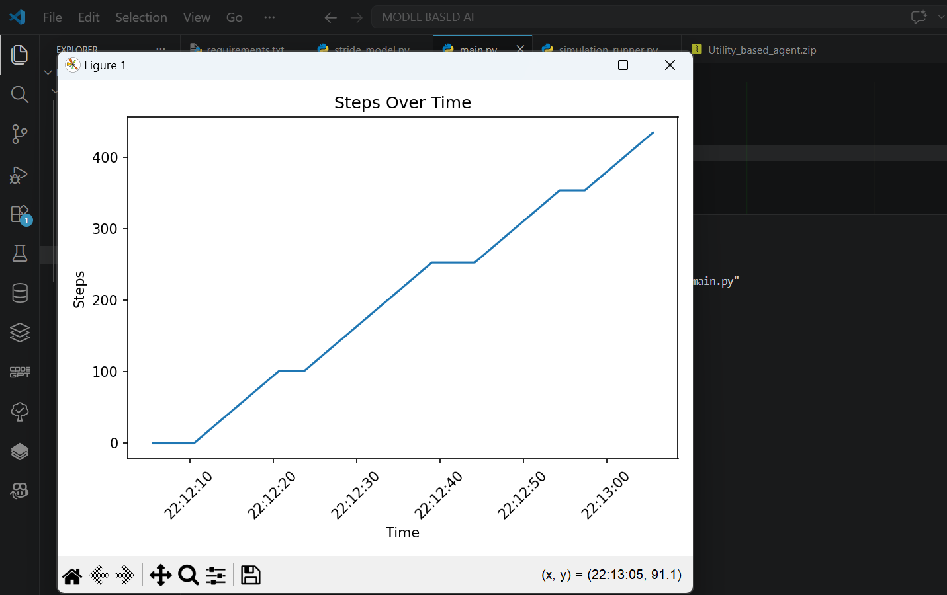

Autonomous Features
System is fully automatic:
- No manual step input
- Continuous simulation loop
- Automatic step detection
- Automatic distance calculation
- Automatic GPS calibration
Works independently (no human control needed)

Logging & History
System stores:
- Time
- Steps
- Distance
Enables tracking and analysis.

Technologies Used
- Python
- NumPy (calculations)
- Matplotlib (graphs)

Conclusion
Key Achievements:
- Built a Model-Based AI Agent
- Implemented step detection system
- Created distance estimation model
- Added learning using GPS calibration
- Visualized results using graphs
This project demonstrates how AI agents can be used in real-world wearable devices.

FINAL PRESENTATION LINE
“This project demonstrates a model-based AI agent that senses movement, learns user behavior, and continuously improves its accuracy in estimating distance, similar to real smartwatches.”
The out put is like here:
